# **The Data I Have and its potential analysis**

## Purchase Orders

### Credit Amount Histogram – Bin width - 15000

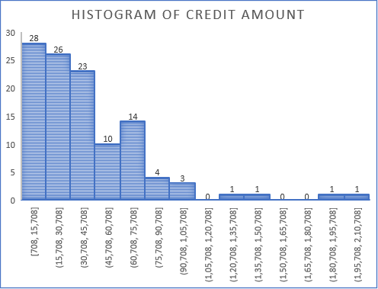

**What**: This graph produces the frequency of credited purchase order amounts for the duration of 6 months.

**Why**: This can be used to determine the most frequent purchase amount made.

**Improvements**: Try to determine the organization and its average purchase amounts. This bar graph can be split on the basis of companies for each bar.

### Descriptive Statistics of Purchase Order Data

|  |  |
| --- | --- |
| **Parameter** | **Value** |
| **Mean** | 40145.51964 |
| **Std. Deviation** | 35422.59946 |
| **Minmium** | 708 |
| **Maximum** | 208447 |
| **Count** | 112 |

**What**: This table comprises of the descriptive statistics for the purchase order data

**Why**: This can be used to understand the structure of the data

**Improvements**: At the moment, none.

### Amount spent on Purchase Orders Based on the Months

**What**: This graph illustrates the sum of all amount placed for purchase orders per month for the duration of the data.

**Why**: Can be used to identify which of the months require the greatest number of purchases and thereby deduce the months where sale *could be the maximum* (max. purchase could mean maximum sale)

**Improvements**: Could identify each of the contribution of each of the companies per month. This can identify the months where this company was relied on the most.

**Table used for this:**

|  |  |
| --- | --- |
| Row Labels | Sum of Credit |
| January | 409002.2 |
| February | 821420 |
| March | 873657 |
| April | 779950 |
| May | 807970 |
| June | 804299 |
| Grand Total | 4496298.2 |

### Count of Purchases Made from various Organizations

**What**: This graph illustrates the number of purchase orders placed against each month for the duration of the data.

**Why**: Can be used to identify the distribution of purchases with respect to the different dealers of the products. This can help in identifying the dependency of each of the companies.

**Improvements**: Can check when purchases were made from other companies and see if there is a possible correlation with respect to the sales data when ever the purchase was made.

**Table used for this:**

|  |  |
| --- | --- |
| Row Labels | Count of Credit Amount |
| APPLE COOKWARE - CURRYLEAF | 2 |
| ARISHTA AGENCIES ( MADURAI) | 10 |
| MAHAVIR HOME APPLIANCES | 93 |
| MP MARKETING | 2 |
| SARASWATHI MARKETING | 5 |
| Grand Total | 112 |

### Sum of Purchases Made from various Organizations – Is this needed?

**What**: This graph illustrates the sum of purchase orders placed against each month for the duration of the data.

**Why**: When coupled with the number of purchases, can be used to determine average amount per purchase.

**Improvements**: Not sure about the relevance of this chart due to the previous chart conveying a similar conclusion. Perhaps, a graph for purchases made for each organization with respect to month can be derived?

**Table used for this:**

|  |  |
| --- | --- |
| Row Labels | Sum of Credit |
| APPLE COOKWARE - CURRYLEAF | 151066 |
| ARISHTA AGENCIES ( MADURAI) | 295120 |
| MAHAVIR HOME APPLIANCES | 3969512.2 |
| MP MARKETING | 6900 |
| SARASWATHI MARKETING | 73700 |
| Grand Total | 4496298.2 |

### Count of all the Product Supplier against month of purchase

**What**: This graph illustrates number of purchases made from each of the respective suppliers.

**Why**: This helps in grouping of suppliers based on reliance and identify the number of purchases made with each of the suppliers of goods. There is a distinct increase of purchase from one of the suppliers in contrast to others. Some of the suppliers are not relied much.

**Improvements**: We can check with the sales data to see if there can be any conclusions drawn from this. Why are Sarawasthi marketing, MP marketing purchase were made during intermediate months? Why is there an increase of purchase? Can something be done regarding this?

**Table used for this:**

|  |  |  |  |  |  |  |
| --- | --- | --- | --- | --- | --- | --- |
| Count of Particulars | Column Labels | |  |  |  |  |
| Row Labels | APPLE COOKWARE - CURRYLEAF | ARISHTA AGENCIES ( MADURAI) | MAHAVIR HOME APPLIANCES | MP MARKETING | SARASWATHI MARKETING | Grand Total |
| January |  |  | 11 |  | 1 | 12 |
| February | 2 | 1 | 13 |  | 2 | 18 |
| March |  | 4 | 17 |  |  | 21 |
| April |  | 2 | 16 | 1 |  | 19 |
| May |  | 1 | 18 | 1 |  | 20 |
| June |  | 2 | 18 |  | 2 | 22 |
| Grand Total | 2 | 10 | 93 | 2 | 5 | 112 |

## Sales Orders

### Debit Amount Histogram – Bin width - 4000

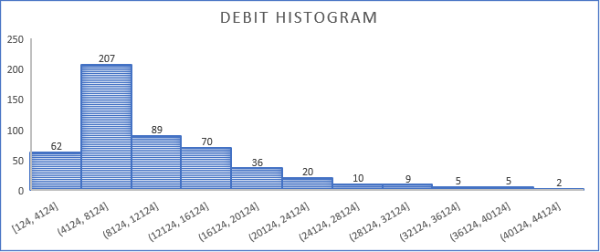

**What**: This graph produces the frequency of debit sales order amounts for the duration of 6 months.

**Why**: This can be used to determine the most frequent sale amount made.

**Improvements**: Try to determine the organization and its average purchase amounts. This bar graph can be split on the basis of companies for each bar.

### Descriptive Statistics of Sales Order Data

|  |  |
| --- | --- |
| **Parameters** | **Value** |
| Mean | 10331.74742 |
| Std.Deviation | 7502.083589 |
| Minimum | 124 |
| Maximum | 43096 |
| Count | 515 |
| Sum | 53,20,849.92 |

**What**: This table comprises of the descriptive statistics for the sales order data

**Why**: This can be used to understand the structure of the data

**Improvements**: At the moment, none.

### Total and Average Sales Revenue per Month

**What**: This combo graph indicates the sum and average sales revenue against the month.

**Why**: There is a difference in trend between the sum and average on that month that indicates the number of transactions. This can help in identifying the number of bulk transactions and can be useful.

**Improvements**: Find a way to identify the number of bulk sales and slight sales.

### Purchaser vs Order per month

**What**: This combo graph indicates the sum and average sales revenue against the month.

**Why**: There is a difference in trend between the sum and average on that month that indicates the number of transactions. This can help in identifying the number of bulk transactions and can be useful.

**Improvements**: Find a way to identify the number of bulk sales and slight sales.

### Frequency of Purchase

**What**: This graph indicates the frequency of purchase made by the purchaser

**Why**: There is a mismatch between the frequency of purchaser and the purchaser vs order graph. That needs to be investigated.

**Improvements**: Why is there a mismatch?

# **The Data I can get and its potential Uses**

## Purchase Orders

1. A pareto chart on average purchases and stacked column for the histogram can be used for identifying the company average amount of purchase in the histogram.
2. A graph that displays the contribution of each company to the purchase order vs month graph can be used for identifying their respective reliance.
3. A multiple line graph indicating purchases made from each organization with respect to month can be derived based on sum of purchases made?